EXPERIMENT – 7
Perform Basic Video Processing Operations: Read a Captured Video in Python and Display It in Normal, Slow Motion, and Fast Motion
Aim
To read a captured video using Python and OpenCV and display the video in normal speed, slow motion, and fast motion.
Procedure
1. Import the OpenCV library.
2. Read the captured video using cv2.VideoCapture().
3. Check whether the video is opened successfully.
4. Read and display the video frame by frame.
5. Display the video in normal speed.
6. Display the video in slow motion by increasing the delay between frames.
7. Display the video in fast motion by decreasing the delay between frames.
8. Release the video capture object and close all windows.
Program
import cv2

cap = cv2.VideoCapture("video.mp4")

while cap.isOpened():
ret, frame = cap.read()

if not ret:
break

cv2.imshow("Normal Speed", frame)
cv2.waitKey(30)

cv2.imshow("Slow Motion", frame)
cv2.waitKey(100)

cv2.imshow("Fast Motion", frame)
if cv2.waitKey(1) & 0xFF == ord('q'):
break

cap.release()
cv2.destroyAllWindows()

Sample Input
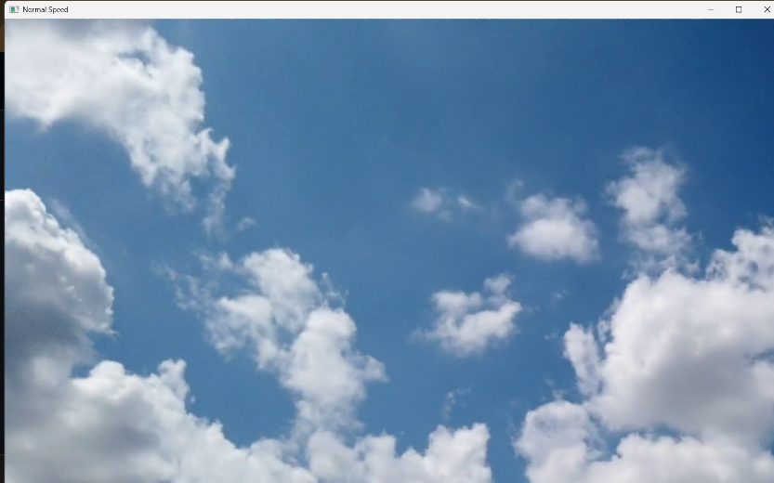
Sample Output
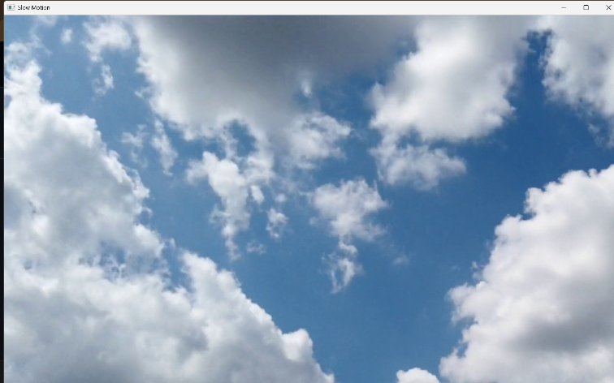
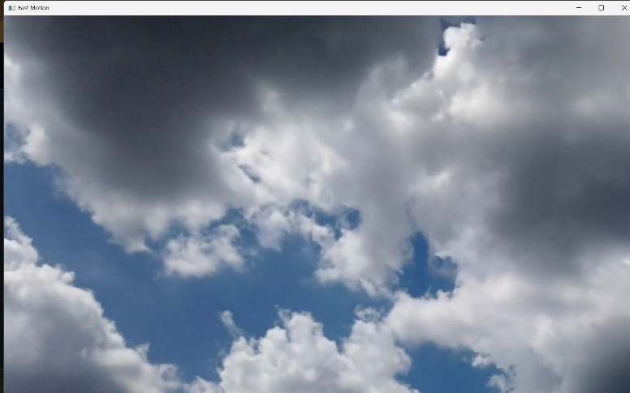
- Normal Speed: Video plays at its normal speed.
- Slow Motion: Video plays slowly.
- Fast Motion: Video plays faster than normal.
Result
Thus, the captured video was successfully read and displayed at normal speed, slow motion, and fast motion using Python and OpenCV.

